Experiment No. 08

Name:- Iqra Shaikh

Roll no:- 24DCO06

Batch :- 01

AIM : Mesh Topology in Cisco Packet Tracer with ip configuration

What is Wireshark?
Wireshark is a free, open-source network traffic analyzer used by security professionals and system administrators. It captures and analyzes live network data to detect issues like dropped packets, latency, or malicious activity.

What does Wireshark do?
Wireshark intercepts traffic and converts that binary traffic into human-readable format. This makes it easy to identify what traffic is crossing your network, how much of it, how frequently, how much latency there is between certain hops, and so forth.
Wireshark intercepts network packets and converts them into human-readable form. It helps identify traffic type, volume, latency, and connections between devices.

Key Uses
- Troubleshoot network issues (packet loss, delays, hacking attempts)
- Monitor TCP, UDP, ICMP traffic
- Detect faulty devices or unusual data transfers

Features
- Supports 2000+ protocols
- Captures live data from Ethernet, Wi-Fi, PPP, USB, etc.
- GUI & command-line (TShark) support
- Display and capture filters for focused analysis
- Edit and convert captures via command-line tools
- VoIP analysis and playback
- Plug-in support for new protocols

Packet Colorization
Packets can be color-coded using filters to easily highlight important traffic. Users can set temporary or permanent color rules.

Capturing Packets
- Open Wireshark → Select your network interface
- Click to start capture → Packets appear in real-time
- Promiscuous mode shows all nearby traffic
- Click Stop to end capture
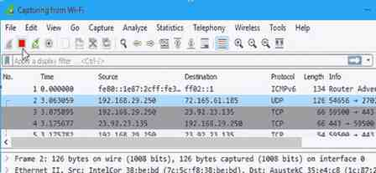

Conclusion
Wireshark is a powerful and essential tool for monitoring and troubleshooting network traffic. Its ability to capture, analyze, and filter real-time data makes it invaluable for identifying performance issues, security threats, and faulty devices. With features like protocol support, packet colorization, and easy capture controls, Wireshark provides deep network visibility in a user-friendly way. It is a must-have tool for network administrators, security analysts, and IT professionals.

